FWA Analytics Platform: Build an application, usings Agentic AI agents with react front end and other modern frameworks covering the below 4 user cases with the underlying sub-usecases. The sub-usecases are just example. Research from the industry practice to add additional sub-usecases

Allow both dark and light mode selection. It is critical that the dashboard and drill / expandion of the details register very high user experience

Application Capabilities:
the application must have intuitive dashboard that provides an executive view of the
potential fraudulent activities for the 4 use-cases and allows drill downs to expand into the types of FWA acivities and associated supported root cause analysis.

- AI-Powered Root Cause Analysis to provide Two Distinct Pathways
- Our AI reasoning engine evaluates multiple hypotheses to determine whether high utilization without outcomes reflects operational challenges or potential fraud. This distinction is important since Each pathway requires different interventions and stakeholder engagement strategies.
  - Operational Issue: Ineffective care model, clinical approach or IT operations and systems problem
  - Fraud: Provider intentionally extending sessions

1. This dashboard shoudl offer drill-down functionality, allowing payers staff to review specific details by provider.
2. Allow a comprehensive view of claims, incidents, and service hours worked on a daily, weekly, monthly, and annual basis.
3. Provide the reporting functionality to ensure claims are accurately validated before payment

In order to demonstrate the function and capabilities of the application, create a detailed set of data to feed the application and illustrate the fraud, waste and abuse insights.

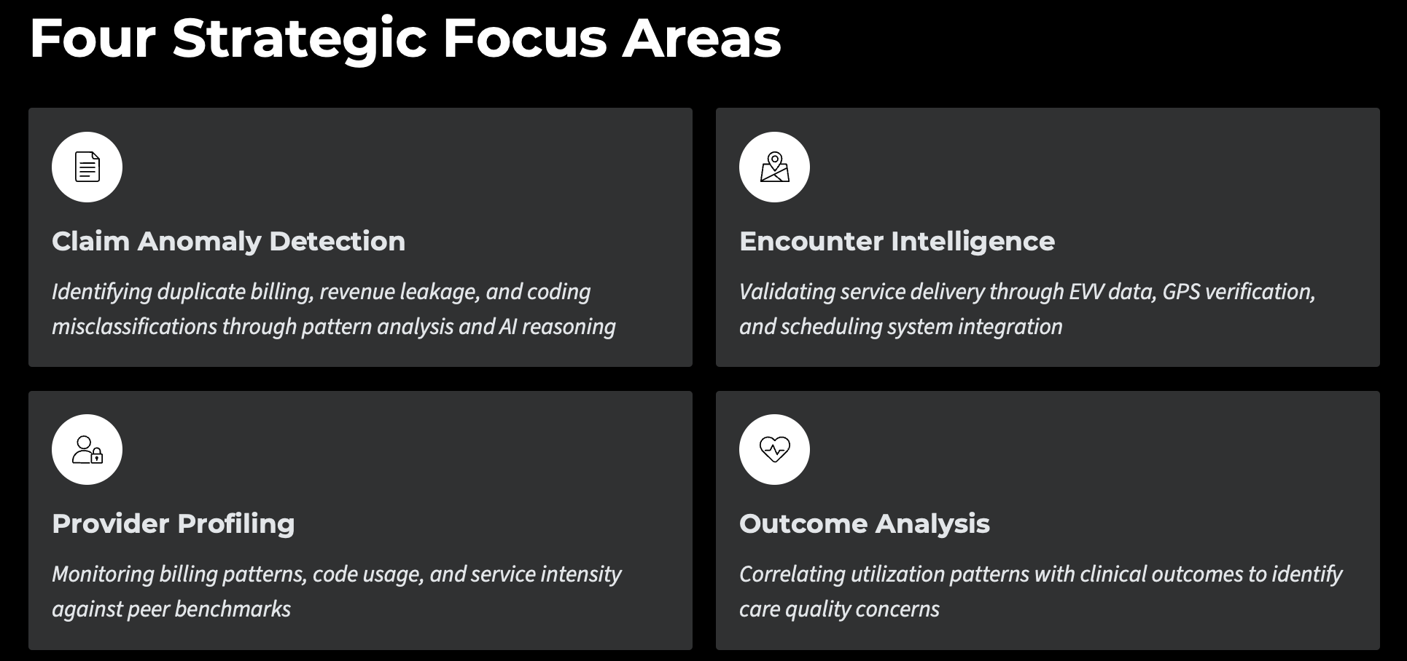
1. Claim Anomaly Detection & Leakage Attribution

Sub-Use Case 1.1 – Duplicate or Shadow Billing
Example: A provider submits two claims for the same service date and member with slightly different procedure codes.
Detection Rules: Match on Member_ID, Provider_ID, Date_of_Service, and Overlapping CPTs. Compare service times and modifiers ( these are 2 character codes appended to the CPT code; 95 is telehealth, 59 is procedural service etc.).
AI Reasoning:
- Operational: EHR auto-resubmitted claim after system timeout
- Fraud: Pattern of duplicates across multiple members from the same provider group
Outcome: Auto-resolves benign duplicates but reports behavior, escalates repeated patterns to Payment Integrity team

Sub-Use Case 1.2 – Underbilling or Missed Charges (Revenue Leakage)
Example: Partial units billed for group therapy sessions due to misconfigured billing rules.
Detection Rules: Authorized_Units - Billed_Units > Threshold. Recurring underbilling in the same procedure code set.
AI Reasoning:
- Operational: Incorrect fee schedule mapping or untrained billing staff.
- Fraud: Rare; more often inefficiency; flagged for operational remediation.
- Add Additional AI reasoning based on the common practices being adopted in this area
Outcome: Prevents lost revenue, informs training or system fixes.

Sub-Use Case 1.3 – Upcoding / Misclassification
Example: Claim submitted for example a 60-minute session when documentation supports only 30 minutes.
Detection Rules: Session_Duration_Documented < Claimed_Duration. NLP review of case notes vs. billing CPT code.
AI Reasoning:
- Operational: Mismatched drop-down or system mapping.
- Fraud: Consistent high time billing pattern across provider above the average visit duration.This could be based on anomaly detection across multiple providers
Outcome: Supports accurate coding, flags potential revenue recovery opportunities.

2. Encounter & EVV Pattern Intelligence

Sub-Use Case 2.1 – Billed but Not Visited
Example: A home-based therapist billed for a session, but EVV shows no GPS check-in.
Detection Rules: EVV_CheckIn_Missing OR GPS_Mismatch > 5 miles. High ratio of non-EVV claims per provider.
AI Reasoning:
- Operational: EVV device sync failure.
- Fraud: Repeated pattern from the same caregiver ID or location.
Outcome: Pinpoints potential ghost visits or falsified service logs.

Sub-Use Case 2.2 – Service Overlap
Example: Two caregivers billed simultaneously for the same member, or the same caregiver billed for multiple clients at once.
Detection Rules: Overlapping_TimeWindows for the same provider or member. Cross-check with EVV and scheduler data.
AI Reasoning:
- Operational: Scheduler double-booking.
- Fraud: Pattern of systematic double billing.
Outcome: Improves scheduling accuracy and fraud deterrence.

Sub-Use Case 2.3 – Missed Visits Not Reported
Example: Caregiver missed two consecutive visits; no incident report filed.
Detection Rules: Planned_Visit – EVV_Visit = Gap AND No_Incident_Record.
AI Reasoning:
- Operational: Unplanned member hospitalization or reassignment not updated.
- Fraud: Concealment of service gaps to avoid non-compliance penalties.
Outcome: Surfaces unreported incidents tied to potential neglect or billing without service.

3. Provider Profiling

Sub-Use Case 3.1 – Outlier Billing Intensity
Example: Behavioral clinic billing four times the average number of high-intensity therapy sessions per patient.
Detection Rules: Provider_Avg_Units > 2 SD above peer group mean. Compare CPT frequency vs. diagnosis codes.
AI Reasoning:
- Operational: Serving higher-acuity population.
- Fraud: Inflated billing intensity with no supporting documentation.
Outcome: Enables risk-based provider auditing.

Sub-Use Case 3.2 – Frequent Code Switching
Example: Provider alternates between codes that yield slightly higher reimbursement.
Detection Rules: Track Code_Shift_Patterns over time. Delta_Reimbursement_Positive without clinical justification.
AI Reasoning:
- Operational: Coding confusion or payer rule change.
- Fraud: Intentional code manipulation pattern detected.
Outcome: Supports compliance education or SIU referral.

Sub-Use Case 3.3 – Weekend or After-Hours Billing Spikes
Example: Large volume of sessions billed on Sundays.
Detection Rules: Time-based anomaly check: Claim_Timestamp outside the normal range.
AI Reasoning:
- Operational: Extended care hours for crisis cases.
- Fraud: Impossible volume during off-hours.
Outcome: Highlights possible ghost claims.

4. Benefit Utilization vs. Clinical Outcomes

Sub-Use Case 4.1 – Overutilization Without Outcome Gain
Example: Member receives 30 therapy sessions in three months with no improvement in PHQ-9 (behavioral measure used in Stars, Hedis reporting)
Detection Rules: High_Service_Volume + Flat_Clinical_Score.
AI Reasoning:
- Operational: Ineffective care model.
- Fraud: Provider extending sessions

5. Claim Anomaly & Leakage Attribution

Sub-Use Case 1.1 – Duplicate or Shadow Billing
Example: A provider submits two claims for the same service date and member with slightly different procedure codes.
Detection Rules: Match on Member_ID, Provider_ID, Date_of_Service, and Overlapping CPTs. Compare service times and modifiers ( these are 2 character codes appended to the CPT code; 95 is telehealth, 59 is procedural service etc.).
AI Reasoning:
- Operational: EHR auto-resubmitted claim after system timeout
- Fraud: Pattern of duplicates across multiple members from the same provider group
Outcome: Auto-resolves benign duplicates but reports behavior, escalates repeated patterns to Payment Integrity team

Sub-Use Case 1.2 – Underbilling or Missed Charges (Revenue Leakage)
Example: Partial units billed for group therapy sessions due to misconfigured billing rules.
Detection Rules: Authorized_Units - Billed_Units > Threshold. Recurring underbilling in the same procedure code set.
AI Reasoning:
- Operational: Incorrect fee schedule mapping or untrained billing staff.
- Fraud: Rare; more often inefficiency; flagged for operational remediation.
Outcome: Prevents lost revenue, informs training or system fixes.

Sub-Use Case 1.3 – Upcoding / Misclassification
Example: Claim submitted for a 60-minute session when documentation supports 30 minutes.
Detection Rules: Session_Duration_Documented < Claimed_Duration. NLP review of case notes vs. billing CPT code.
AI Reasoning:
- Operational: Mismatched drop-down or system mapping.
- Fraud: Consistent 60-minute billing pattern across provider despite average visit duration of 25 minutes.
Outcome: Supports accurate coding, flags potential revenue recovery opportunities.

2. Encounter & EVV Pattern Intelligence

Sub-Use Case 2.1 – Billed but Not Visited
Example: A home-based therapist billed for a session, but EVV shows no GPS check-in.
Detection Rules: EVV_CheckIn_Missing OR GPS_Mismatch > 5 miles. High ratio of non-EVV claims per provider.
AI Reasoning:
- Operational: EVV device sync failure.
- Fraud: Repeated pattern from the same caregiver ID or location.
Outcome: Pinpoints potential ghost visits or falsified service logs.

Sub-Use Case 2.2 – Service Overlap
Example: Two caregivers billed simultaneously for the same member, or the same caregiver billed for multiple clients at once.
Detection Rules: Overlapping_TimeWindows for the same provider or member. Cross-check with EVV and scheduler data.
AI Reasoning:
- Operational: Scheduler double-booking.
- Fraud: Pattern of systematic double billing.
Outcome: Improves scheduling accuracy and fraud deterrence.

Sub-Use Case 2.3 – Missed Visits Not Reported
Example: Caregiver missed two consecutive visits; no incident report filed.
Detection Rules: Planned_Visit – EVV_Visit = Gap AND No_Incident_Record.
AI Reasoning:
- Operational: Unplanned member hospitalization or reassignment not updated.
- Fraud: Concealment of service gaps to avoid non-compliance penalties.
Outcome: Surfaces unreported incidents tied to potential neglect or billing without service.

3. Provider Behavioral Profiling

Sub-Use Case 3.1 – Outlier Billing Intensity
Example: Behavioral clinic billing four times the average number of high-intensity therapy sessions per patient.
Detection Rules: Provider_Avg_Units > 2 SD above peer group mean. Compare CPT frequency vs. diagnosis codes.
AI Reasoning:
- Operational: Serving higher-acuity population.
- Fraud: Inflated billing intensity with no supporting documentation.
Outcome: Enables risk-based provider auditing.

Sub-Use Case 3.2 – Frequent Code Switching
Example: Provider alternates between codes that yield slightly higher reimbursement.
Detection Rules: Track Code_Shift_Patterns over time. Delta_Reimbursement_Positive without clinical justification.
AI Reasoning:
- Operational: Coding confusion or payer rule change.
- Fraud: Intentional code manipulation pattern detected.
Outcome: Supports compliance education or SIU referral.

Sub-Use Case 3.3 – Weekend or After-Hours Billing Spikes
Example: Large volume of sessions billed on Sundays.
Detection Rules: Time-based anomaly check: Claim_Timestamp outside the normal range.
AI Reasoning:
- Operational: Extended care hours for crisis cases.
- Fraud: Impossible volume during off-hours.
Outcome: Highlights possible ghost claims.

4. Benefit Utilization vs. Clinical Outcomes

Sub-Use Case 4.1 – Overutilization Without Outcome Gain
Example: Member receives 30 therapy sessions in three months with no improvement in PHQ-9 (behavioral measure used in Stars, Hedis reporting)
Detection Rules: High_Service_Volume + Flat_Clinical_Score.
AI Reasoning:
- Operational: Ineffective care model.
- Fraud: Provider extending sessions

